SET 1

Q1. (Algorithms – 5 Marks)
Use AI to write Python code for Quick Sort.
Sort the array:
[90, 12, 77, 23, 5, 41, 68]
Explain AI’s suggestions for pivot selection.
Code:
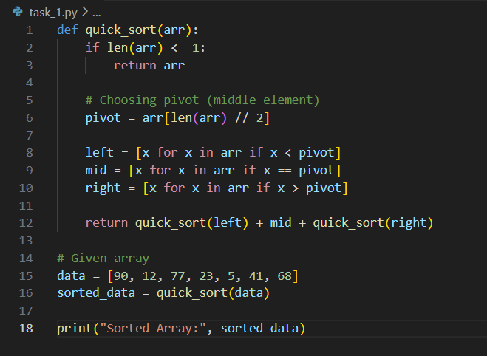
Output:
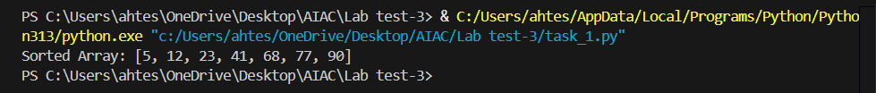

Q2. (Frontend – 5 Marks)
With AI help, create a webpage showing live digital clock using JavaScript.
Format: HH:MM:SS AM/PM
Style using AI-generated CSS.
Code:
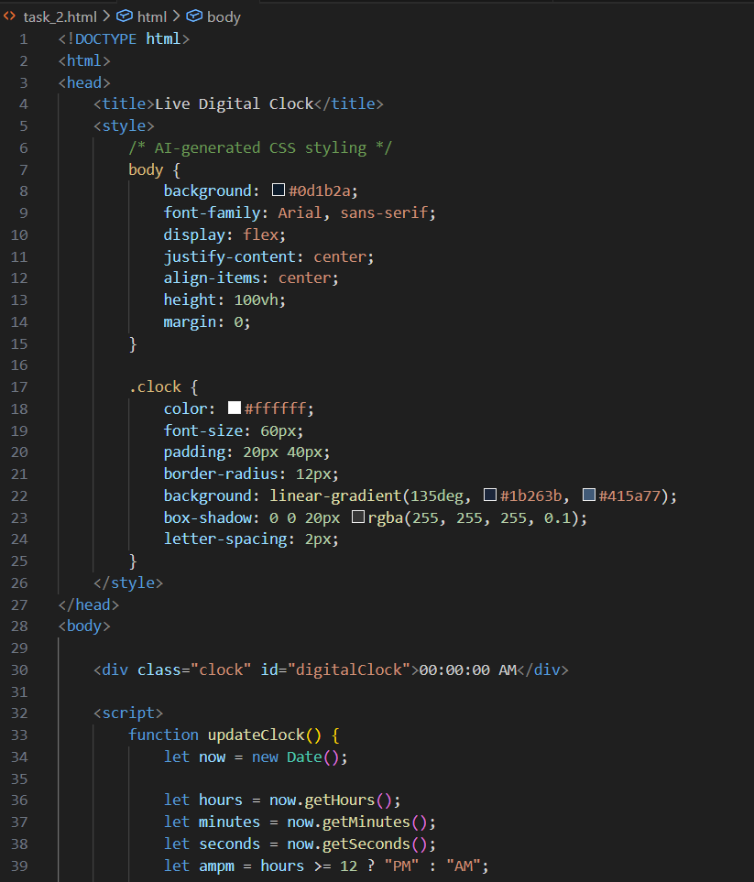
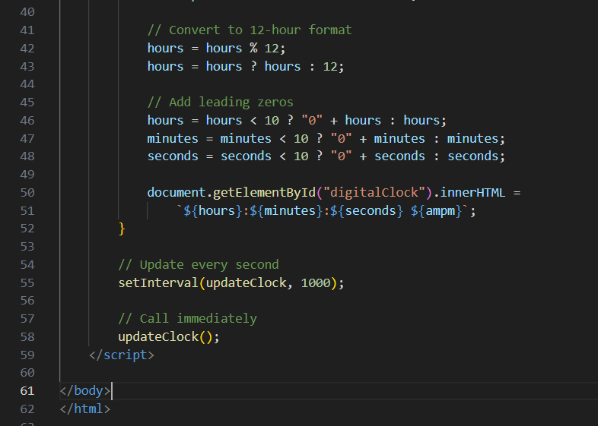
Output:

=====================================================================================

SET 2

Q1. (Data Structures – 5 Marks)
Using AI, create a Python implementation of a Binary Search Tree (BST) with:
- Insert
- Inorder traversal
- Search operation
Demonstrate all operations with sample input.

Q2. (Algorithms – 5 Marks)
Use AI to write Python code for Linear Search with early exit optimization.
Apply it on a list of 20 elements.
Display number of comparisons.

============================================================

SET 3

Q1. (Algorithms – 5 Marks)
With AI, generate a Python script to implement Fibonacci sequence using Dynamic Programming (tabulation).
Print first 15 values and compare runtime with a recursive version.

Q2. (Frontend – 5 Marks)
Use AI to build a student marks dashboard using HTML + CSS + JS.
Features:
- Input fields
- Button to calculate total and grade
- Display result dynamically

============================================================

SET 4

Q1. (Algorithms – 5 Marks)
Use AI to generate Python code that finds the minimum and maximum in an array using the divide and conquer approach.
Test with a 12-element list.

Q2. (Frontend – 5 Marks)
With AI assistance, generate a webpage containing an image gallery arranged in a 3-column responsive grid.
Add JavaScript for image enlargement on click.
=====================================================================

SET 5

Q1. Data Structures & Algorithms (5 Marks)
Using AI assistance, write a Python script to implement Merge Sort.
Your script should:
- Take a list of unsorted integers as input
- Use Merge Sort to sort the list
- Print each merge step (showing how subarrays are combined)

Q2. (Web Frontend – 5 Marks)
With AI assistance, generate a your personal Portfolio Website including

